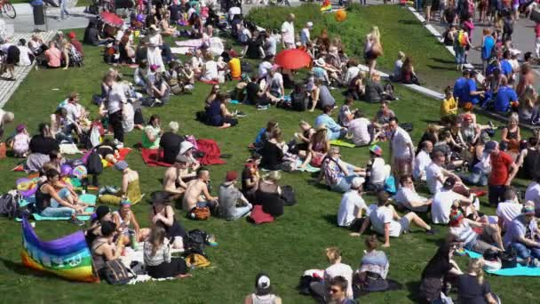

**THANK YOU DAY BIG PICNIC**

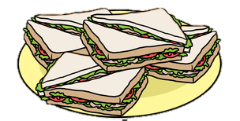

**Bring a blanket**

**Bring a picnic**

**& Celebrate**

**“Thank you Sunday” with us**

**Eating together in**

**St Andrew’s garden**

**after the 10 o’clock Service**

Sunday 4th July